Joseph Ayo

Module 8.2 Assignment – CSD 325

Output:  
  
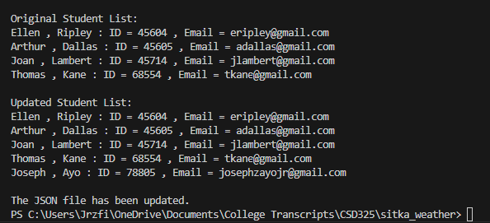

JSON File Contents:  
[

{

"F_Name": "Ellen",

"L_Name": "Ripley",

"Student_ID": 45604,

"Email": "[eripley@gmail.com](mailto:eripley@gmail.com)"

},

{

"F_Name": "Arthur",

"L_Name": "Dallas",

"Student_ID": 45605,

"Email": "[adallas@gmail.com](mailto:adallas@gmail.com)"

},

{

"F_Name": "Joan",

"L_Name": "Lambert",

"Student_ID": 45714,

"Email": "[jlambert@gmail.com](mailto:jlambert@gmail.com)"

},

{

"F_Name": "Thomas",

"L_Name": "Kane",

"Student_ID": 68554,

"Email": "[tkane@gmail.com](mailto:tkane@gmail.com)"

},

{

"F_Name": "Joseph",

"L_Name": "Ayo",

"Student_ID": 78805,

"Email": "[josephzayojr@gmail.com](mailto:josephzayojr@gmail.com)"

}

]